**Bread** & **Butter Sell Setups**

Sell Program

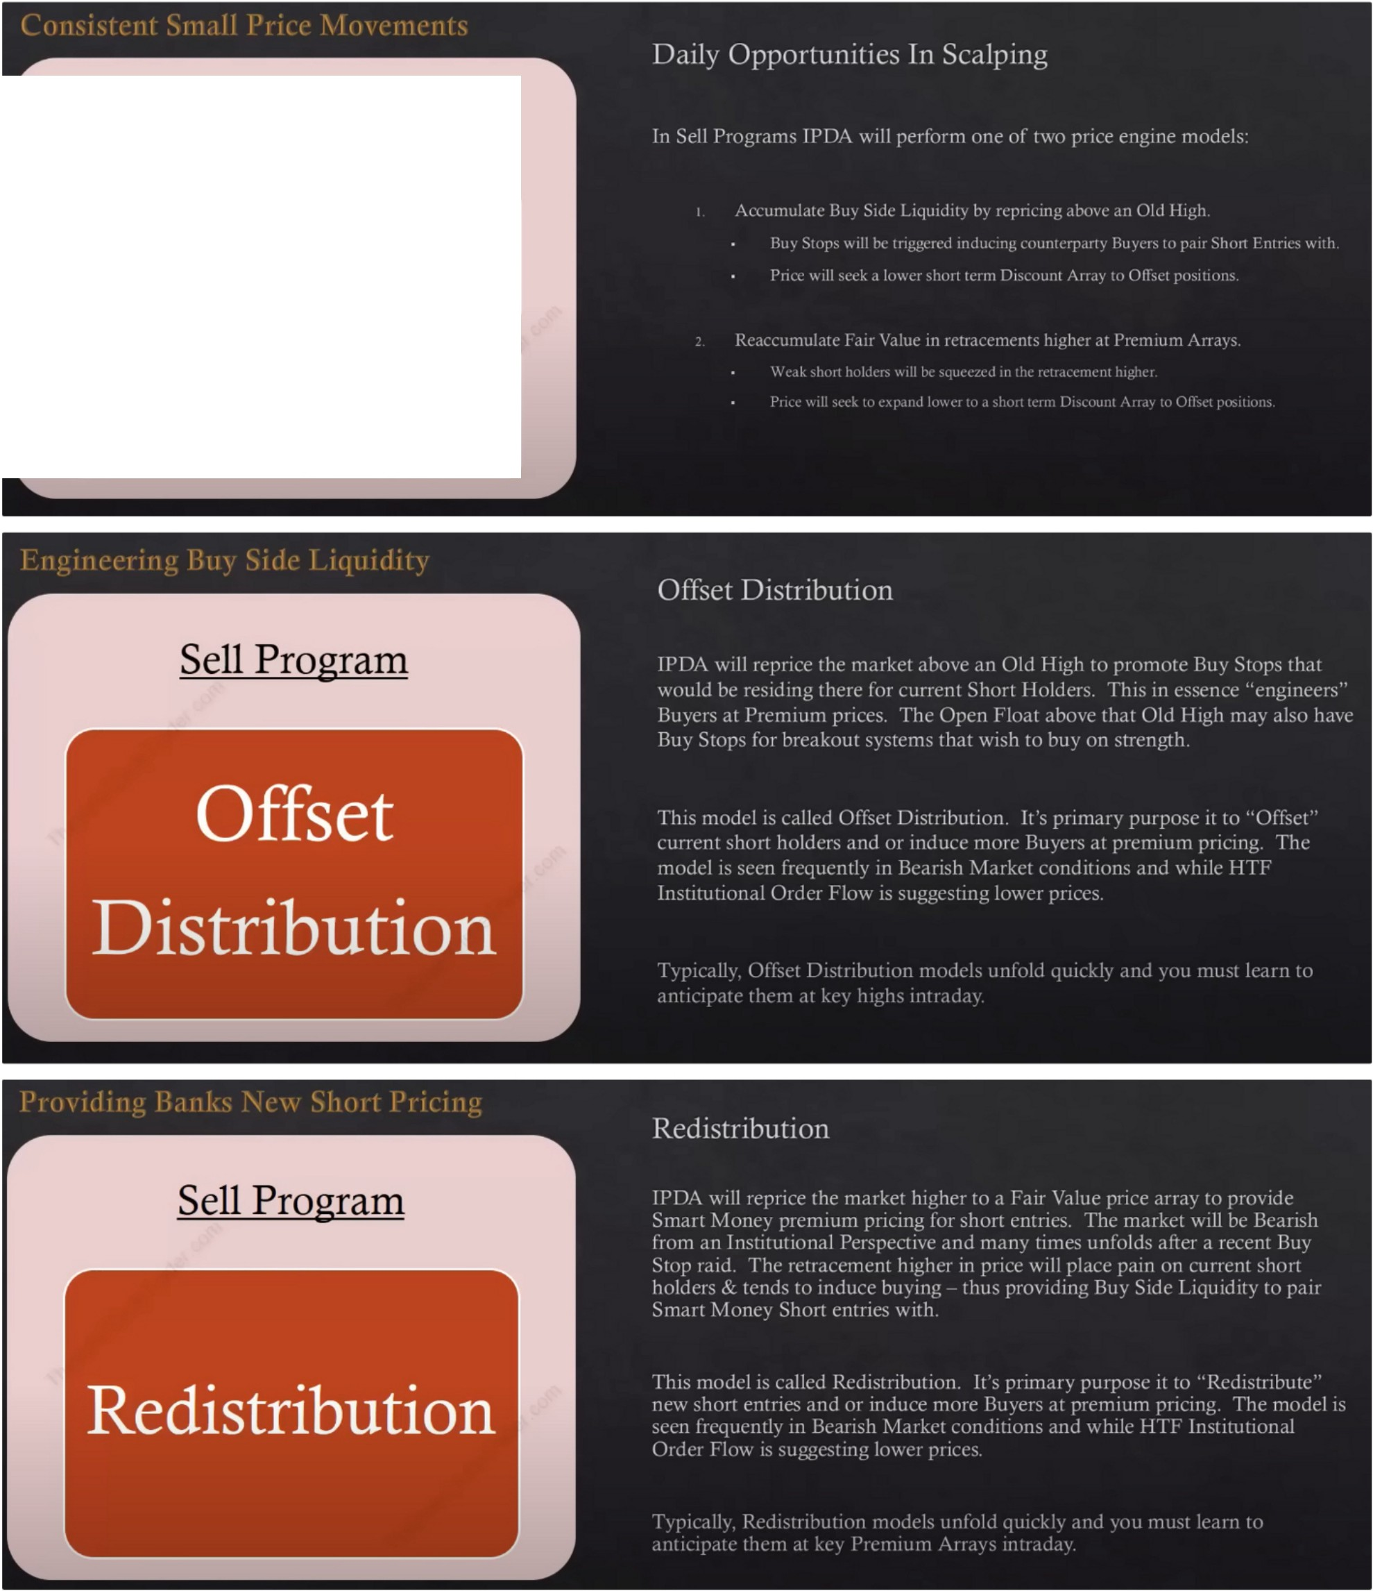

Offset Distribution

Redistribution

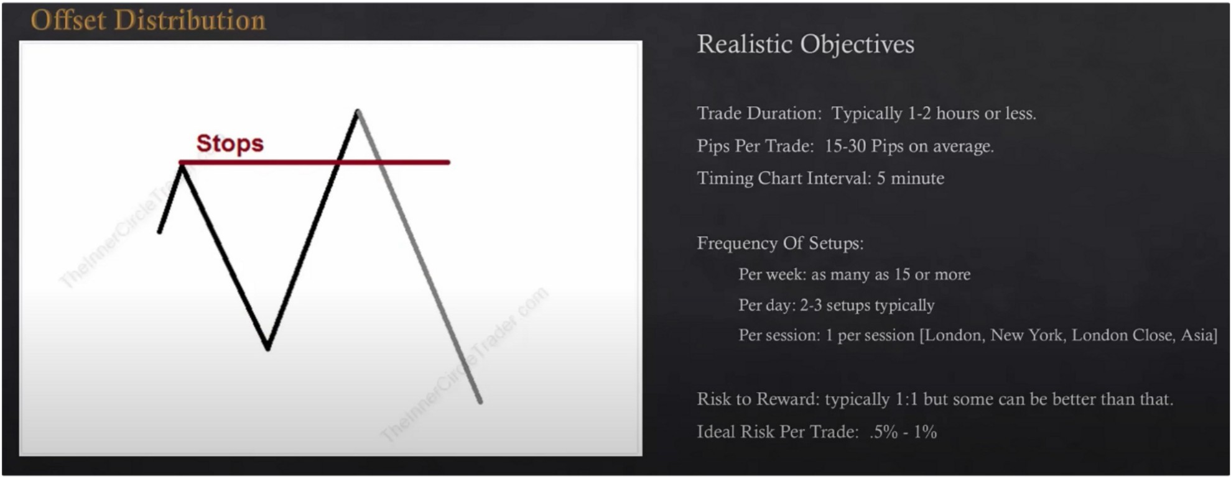

ICT is not going to rehearse everything, its the same as the previous teaching just in reverse

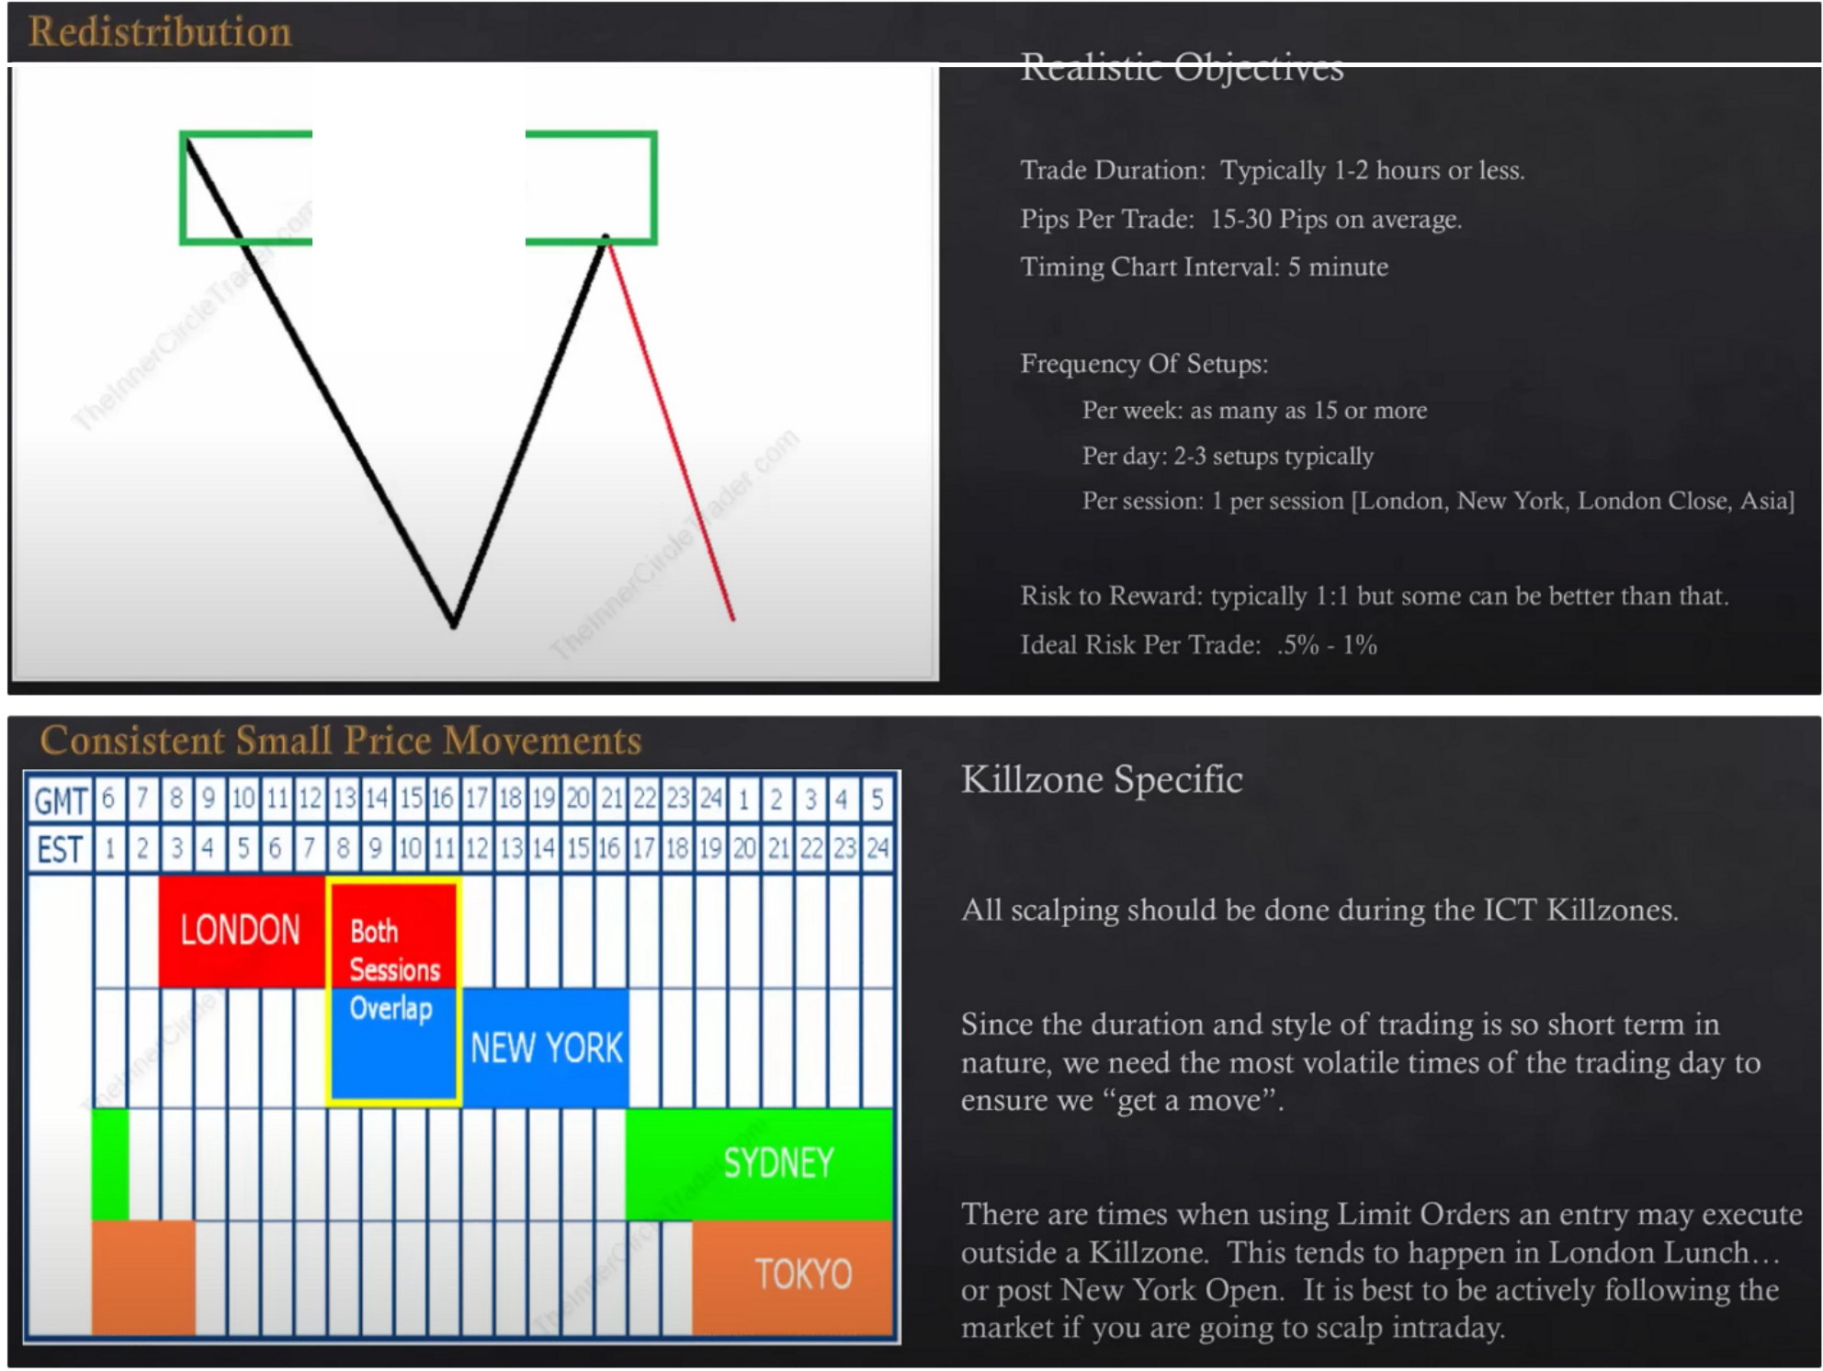

**Fair Value**

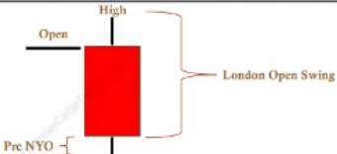

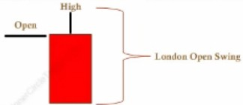It doesnt have to have a rally above the opening price, it can happen and will likely happen tho

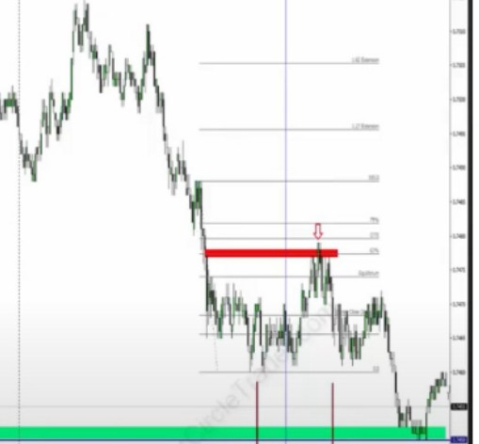

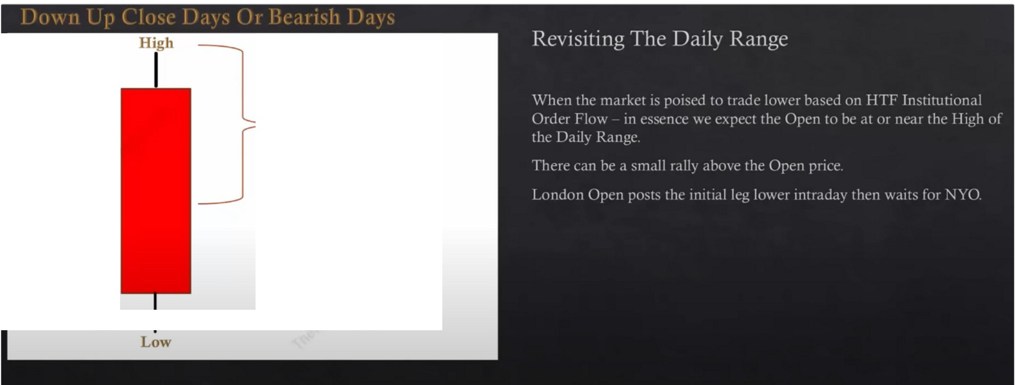

Open

London Open Swing

**WO{--+-----**

5DayADRLow

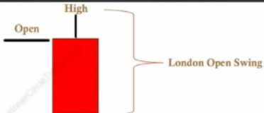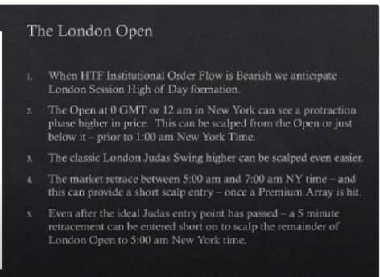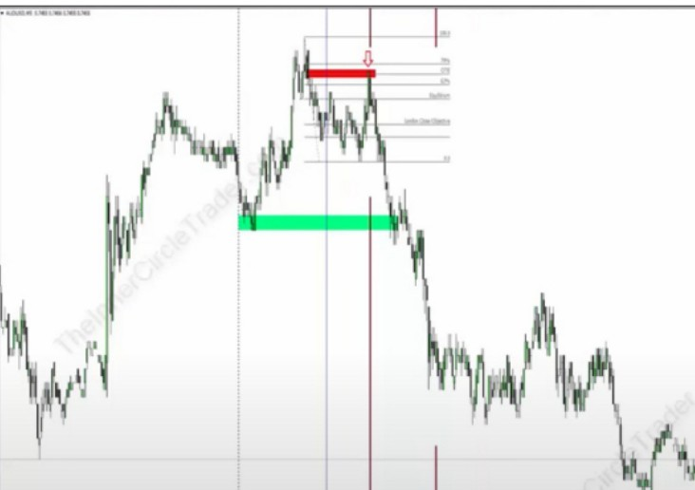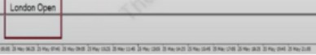

A re-distribution

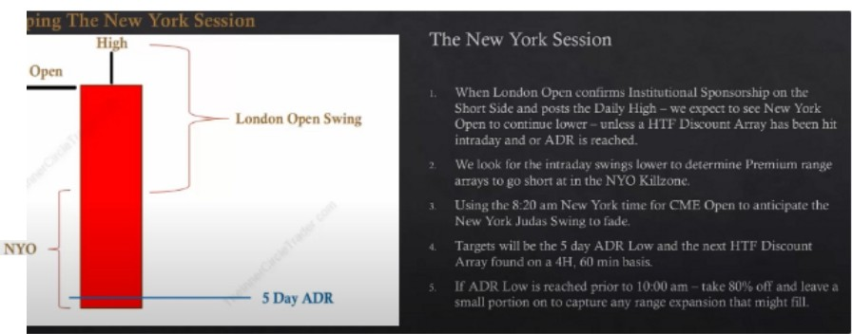

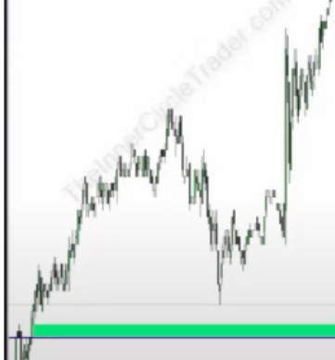

A re-distribution

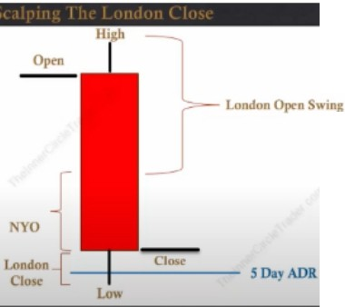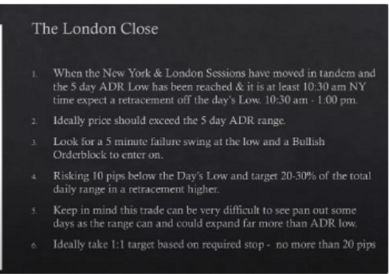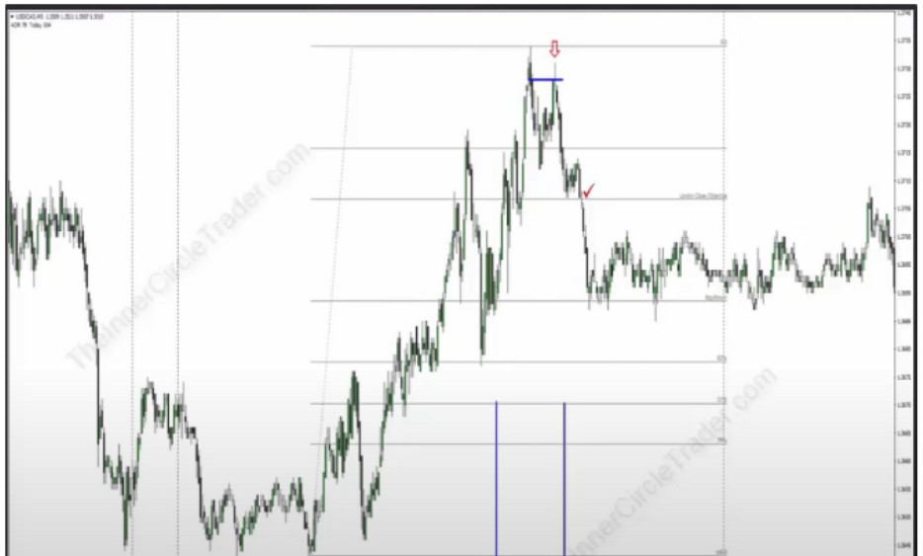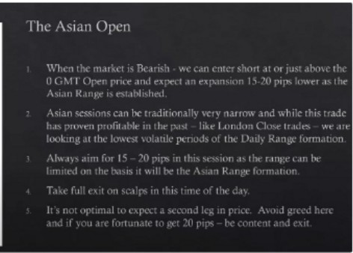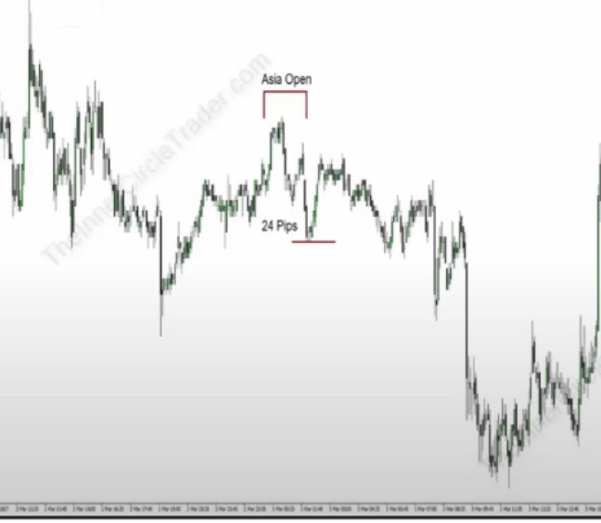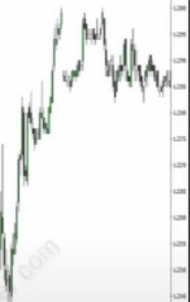

The ADR, average daily range

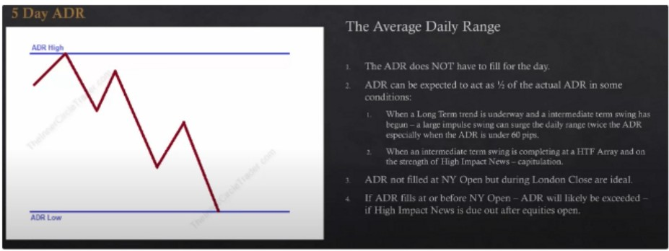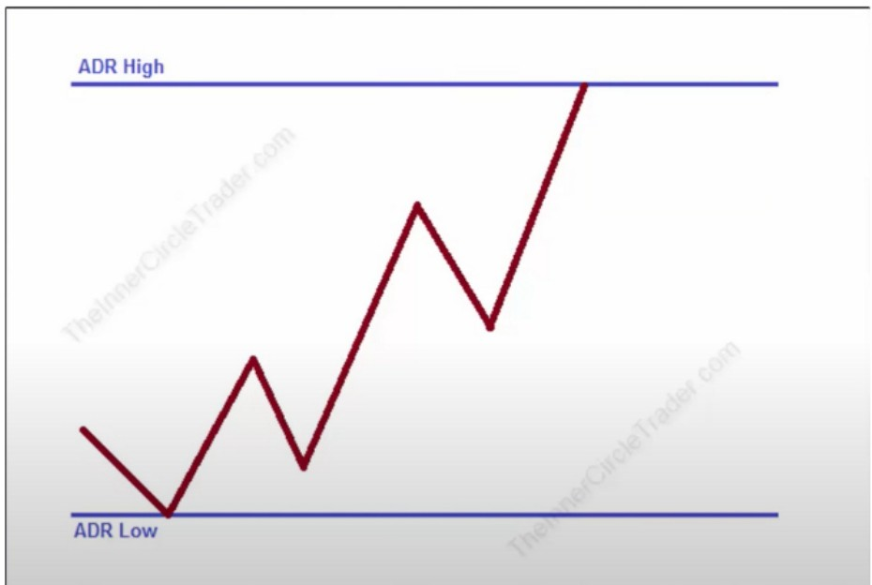

Many times price will just fall short of the ADR or it will wildly exceed it. Its a general rule of thumb and will give us a range we can reach for where we can blend PD arrays on the LTF upto a 1h or 4h chart and blending it with the pivot points, the CBDR, asian range, flout. When all these things overlap it will help formulate a probable objective for the day. Until that objective is met, and in between those ranges we can see scalps form. Ideally 1 in London, 1 in New York and 1 in London close and maybe asia open.

60 pips or less and the conditions are likely that we'll see an obvious impulse higher or lower expecting a large range, chances are we could see the ADR double.

Capitutlation is when the move has been going on for a while to reach the PD array, then on the last day price will rush to get there then we can expect double the ADR

You cant expect ADR to always fill, back off the ADR about 15 pips before the high or low

So whatever the ADR low or high is, we want to scale positions off about 15 pips before that number. Atleast thats what ICT does, because he's taking the low hanging fruit

Equities open is stock market open 930

Its just a tool, it compliments everything else in our toolbox, is essential that we see ADR on our chart? NO. But we now have the tools where the probable expansion is.

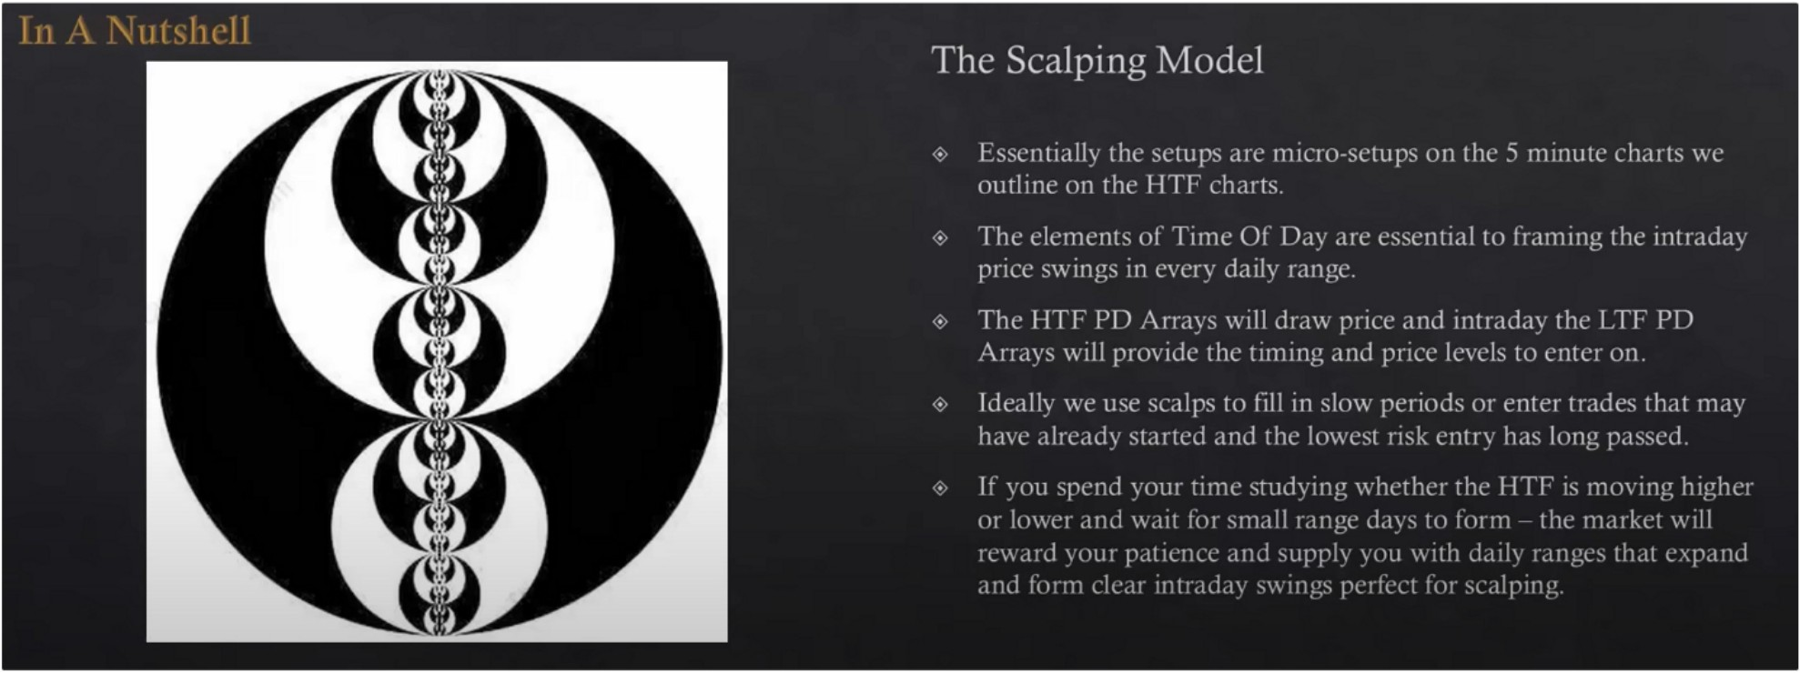

Important: The HTF PD arrays will draw price and intraday LTF PD arrays will provide the timing and price levels to enter on

Just because were in smaller ranges doesnt equate to: "Im just going to scalp the market" there still has to be volatility, we like to see large range days, expansion is where we are very profitable

The other models will compliment eachother, if you have enough margin you can scalp and still look at the other models. Scalping can be used as hedging, or if you missed the move for the daytrade or one shot one kill for example.

You can do very well with this, but its not every day trading. If you allow it it will take you away from the HTF charts and thats NOT what we want, you need the HTF thats why we focus so much time on the HTF and not on the LTF, if you dont have the tools from every teaching, scalping is going to be a problem for you.

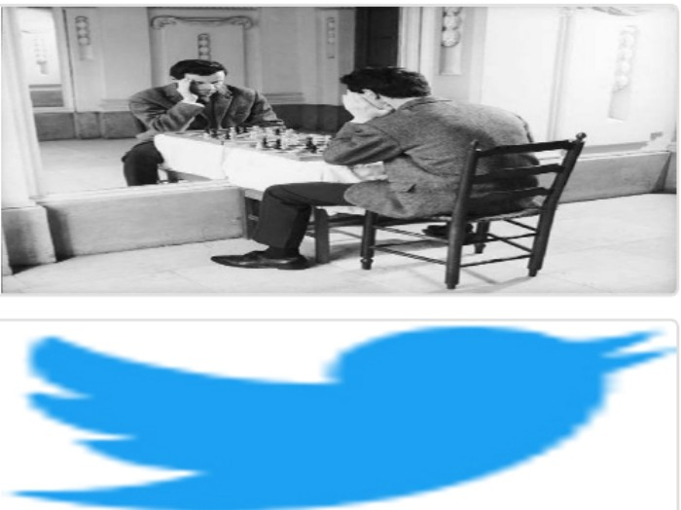Arjo I Twitter, lnstagram I Linktree

Linktree. Make your link do more.

, https://t.co/HhmmTN1fUI

JavaScript is not available.

*"JI* https://twitter.com/arjoio